

pIWIK PRO SHAREPOINT analytics – Tag Manager - automatic updatE

SharePoint Server

Version 1.0.0

Contents

1. Introduction 1

1.1 Prerequisites 1

2. Updating tag manager on sites 1

2.1 Upload a tag manager file into the Style Library 1

2.2 Edit sites status in Piwik PRO Directory list 4

# Introduction

This is a manual how to update and publish automatically Tag Manager json file on installed Piwik PRO connector instance.

## Prerequisites

Sharepoint server with installed Piwik PRO Connector.

# 2. Updating tag manager on sites

## 2.1 Upload a tag manager file into the Style Library

Go to the PiwikAdmin (it is a site with the url: {your webapplication url}/sites/PiwikAdmin)

Then go to Style library > PROD folder.

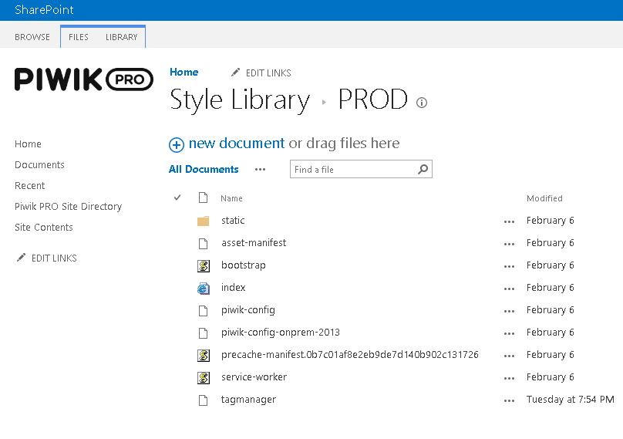

There you need to upload file with the name: “tagmanager.json”.

If the element is checked out after upload then select document and click on “Check In”

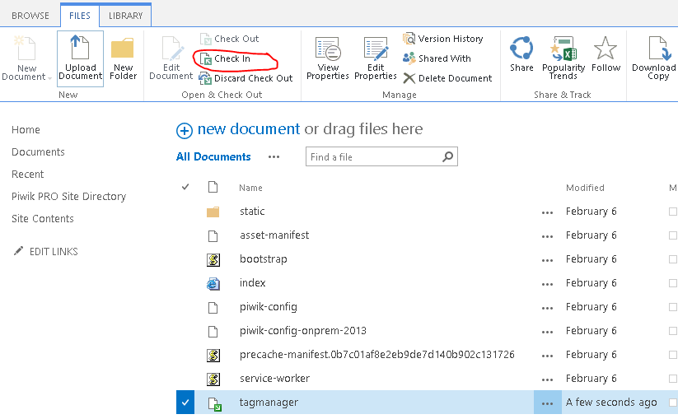

Then select publish and click OK.

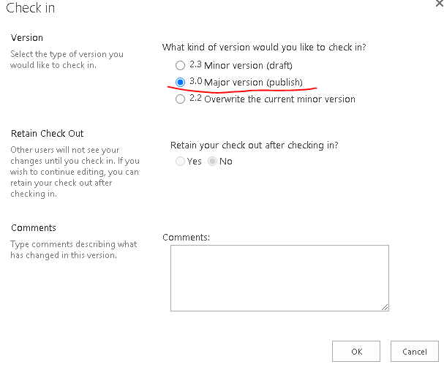

## 2.2 Edit sites status in Piwik PRO Directory list

Go to Piwik PRO Site Directory list in PiwikAdmin site.

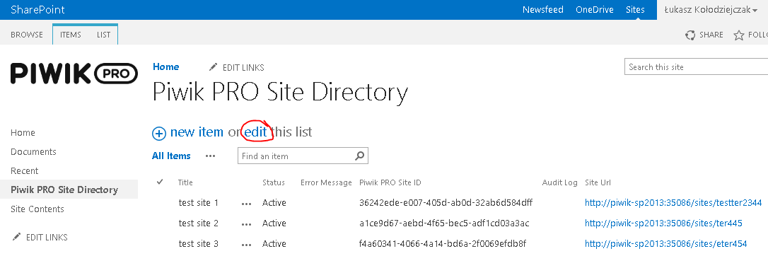

Click “edit this list” and then change value of “Status” column on the row of site which you want to update tag manager file into “Settings updated”.

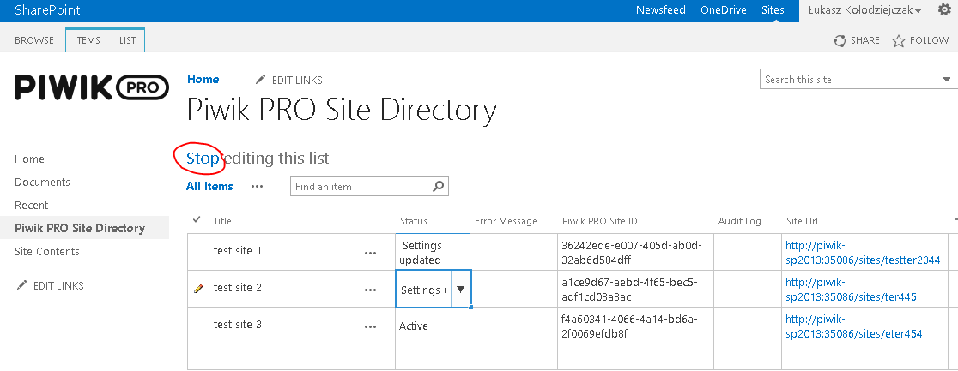

Then click “Stop editing this list”.

After one hour if timer job run the Statuses will be changed again to “Active” and tag manager file will be updated and published.